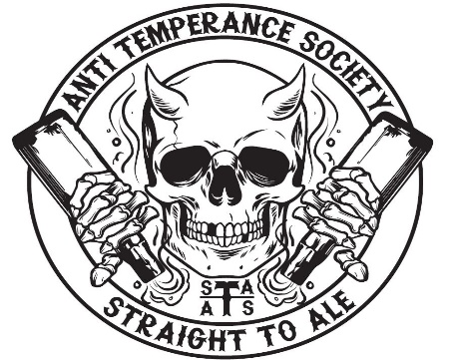
ANTI TEMPERANCE SOCIETY
STRAIGHT TO ALE LOYALTY CLUB

NEW MEMBER APPLICATION

Today’s Date:_________________ Yearly or Semester:______________

Name:_________________________________________________________

Email:_________________________________________________________

T-shirt size (unisex, circle one): S M L XL XXL 3XL

To officially become a member of the Anti Temperance Society, give this form and your Yearly or Semester membership fee to a bartender. Yearly membership is $200+tax and a semester membership is $100+tax. Fall semester runs from August thru December and spring semester runs from January thru May. Joining in the middle of the semester is the same price, but you will be able to get the monthly crowlers for the months in the semester which you missed.

(FOR STA EMPLOYEE USE ONLY)

AMOUNT PAID:__________________ DATE PAID:________________________

PAYMENT METHOD (CIRCLE ONE): CC CASH CHECK

DATE MEMBERSHIP PROCESSED BY ROADKILL: _______________________

MEMBER NUMBER:_______________

